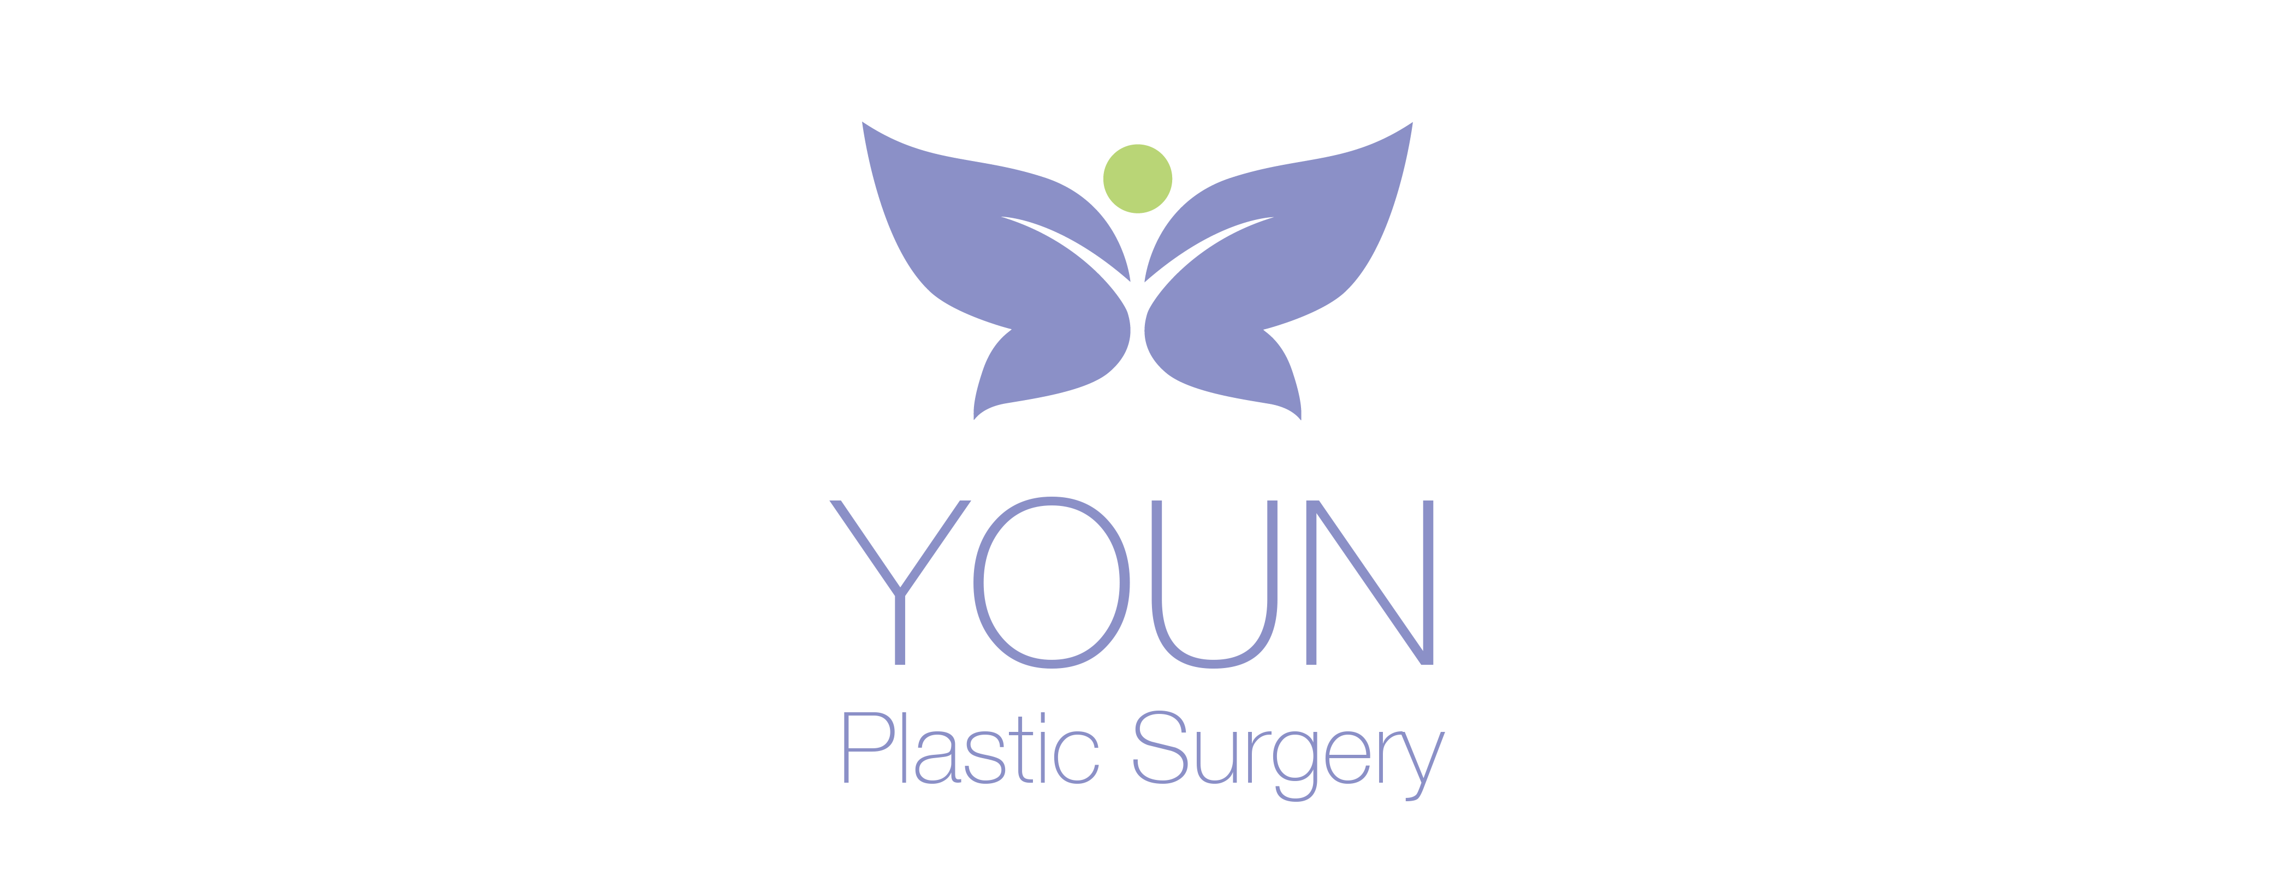

Receipt of Notice of Privacy Practices
Written Acknowledgement Form.

I, ____________________, have received a copy of YOUN Plastic Surgery’s
Patient Name
Notice of Privacy Practices.

I give the following people permission to have access to my medical records; this remains in effect unless otherwise withdrawn in writing:

Name: __________________________________ Relationship:_____________________

Name: __________________________________ Relationship:_____________________

Name: __________________________________ Relationship:_____________________

_________________________ _________________
Signature of Patient Date

