COVID-19 INFORMED CONSENT AGREEMENT

I, the undersigned patient, consent to have my Doctor and/or his/her staff (hereinafter collectively “my Doctor”) perform medical procedures, whether regarded as necessary, elective or aesthetic, during the time of the COVID-19 pandemic and after. I understand having my procedure performed at this time, despite my own efforts and those of my Doctor, may increase the risk of my exposure to COVID-19. I am aware that exposure to COVID-19 can result in severe illness, intensive therapies, extended intubation and/or ventilator support, life-altering changes to my health, and even death. I am also aware of the possibility that the procedure itself, whether performed in my Doctor’s office or in a hospital, may result in a more severe case of COVID-19 than I might have had without the procedure.

I also understand having my procedure performed at this time increases the risk of my transmission of COVID-19 to my Doctor. This virus has a long incubation period, there may be as yet unknown aspects of its transmission, and I realize that I may be contagious, whether or not I have been tested or have symptoms. To reduce the possibility of COVID-19 exposure or transmission at my Doctor’s office, I accept that my Doctor will implement infection-control procedures with which I must comply, before, during and after my procedure, for my own protection as well as that of my Doctor. I understand my cooperation is mandatory, whether or not I personally feel such COVID-19 procedures and/or preventive measures to be necessary.

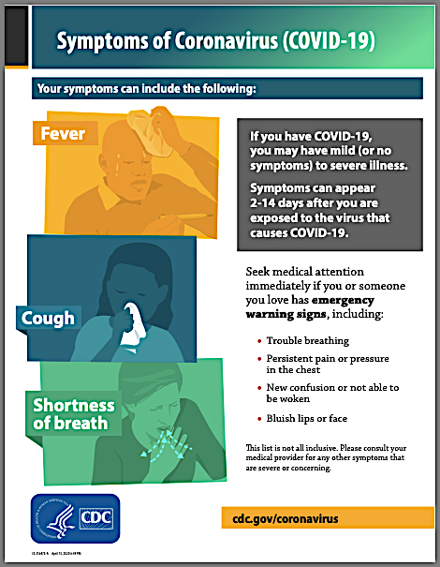
I have informed my Doctor of any COVID-19 testing I or any person living with me during the past 14 days has received, as well as the results of that testing, and if I am tested between now and the date of my procedure, I will immediately provide the results of that testing to my Doctor. I understand my Doctor may require that I be tested, possibly at my own expense and regardless of any prior testing, and that the results of that testing must be satisfactory to my Doctor, before I may receive my procedure.

I confirm neither I nor any individual living with me has any of the COVID-19 symptoms listed by the Centers for Disease Control https://www.cdc.gov/coronavirus/2019-ncov/downloads/COVID19-symptoms.pdf, which website I have consulted; neither I nor any individual living with me during the past 14 days has experienced any such symptoms; and that I and all persons living with me for the past 14 days have practiced all personal hygiene, social distancing and other COVID-19 recommendations contained within all governmental orders issued by my city and state. I understand I must honestly disclose this information to avoid putting myself and others at risk.

All topics above have been discussed with me, and all my questions have been answered to my satisfaction. Being fully informed, I accept the risk of COVID-19 exposure and I will bear the cost of any COVID-19 treatments required. I have been given the opportunity to postpone my procedure until the COVID-19 pandemic is less prevalent, but I choose to have my procedure performed now. If I am the parent, guardian or conservator of the patient, I hold his/her health care power of attorney. I have read this COVID-19 Informed Consent Agreement and am authorized to consent on the patient's behalf.

Patient/Authorized Representative Signature and Initials Print Name & Date [First encounter]

Patient/Authorized Representative Signature and Initials Print Name & Date [Day of procedure]

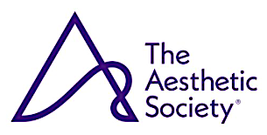
Notice and Disclaimer. Medical information changes constantly. This COVID-19 Informed Consent Agreement sets forth the current recommendations of The Aesthetic Society, is provided for informational purposes only, and does not establish a new standard of care. April 25, 2020

